

|  |  |  |
| --- | --- | --- |
| MANUAL | **NEWTON’S RING** | |
| M/s TEXLA SCIENTIFIC INSTRUMENTS #3-3-593, CHAPPAL BAZAR, HYDERABAD – 500 027 MOBILE: 9440108331 , TELEFAX: 040- 24652326 | | CAT No:1067 |

**NEWTON’S RINGS**

**Aim:** - To determine the wavelength 𝝀 of the light emitted by Source by forming Newton’s rings.

**Apparatus:** -Sodium vapour lamp or Mercury vapour lamp, Newton’s ring.

**Theory:**  -When a Plano-convex lens with its convex surface is placed on a plane glass plate, an air film of gradually increasing thickness is formed between the two.

If a monochromatic light is allowed to fall normally on this combination and the combination is viewed in fig., then a pattern of alternate light and dark circular rings can be observed.

These circular fringes are called Newton’s rings. The fringes are circular because the air film has a circular symmetry. They are formed because of interference between waves reflected from the top bottom surfaces of the air film formed between the plates.

1. To observe sustained interference in light during an optical experiment two conditions must be satisfied.
2. The sources must be coherent that is they must maintain a constant phase difference.
3. They must be monochromatic
4. In young’s double slit experiment and Fresnel’s biprism the condition for dark fringes is d sinθ=(m+⅟2)𝝀 (m=0,1,2….)

Here the interference is due to the division of wave front.

1. Interference is possible by the division of amplitude.

Interference effects are commonly observed in thin films. Consider a film of uniform thickness t and refractive index n.

180o phase change No phase change

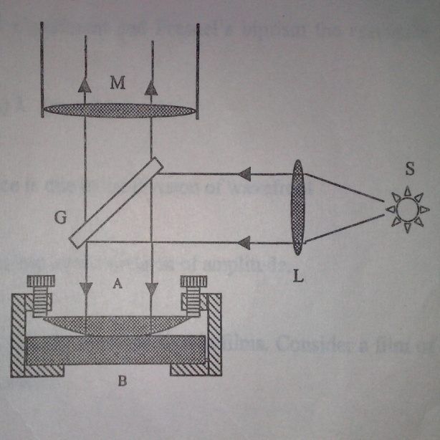

N i

Film

B

Air

Air

A

Let us assume that light rays in air are nearly normal to the surfaces of the film. In this case interference occurs when light rays reflected from upper and lower surfaces of the film combine.

The equation for destructive interference is 2µt=m𝝀 (m=0, 1, 2…..) where µ is the refractive index of the medium and µ=1 for air.

A similar situation exists in the Newton’s rings set up. On looking through the microscope alternate yellow and dark rings will be seen. Definition of the rings can be improved small adjustments reflecting glass plate and source. The innermost rings are avoided as they are not quite circular.

Set the point of intersection of the cross wires at the centre of the ring system. Rotate the microscope about its axis, so that one cross wire is at right angles to the direction of motion of the microscope and the other parallel to it. This will enable us to make the vertical cross wire tangential to any of the rings.

Set the cross wire tangential to say the 15th dark ring on ONE side (say the left hand side) of the central dark. Spot counting the central dark spot as zero. Read the microscope position. The main scale has 90 millimetres engrave on it. The least count is 1mm/100=0.01mm. Because when the micrometer head is turned through 1 complete revolution it means a distance of 1mm. on the main scale. To take any reading the procedure is to record it as follows

(M.S.R in mm + x (0.01mm)) where x is the number indicated on micrometer head.

Repeat the procedure till the 5th dark ring on the left appears in the field of view. Move on, turning the screw in the same direction till the vertical cross wire is successively tangential to 5th dark ring on right, 6th dark ring on right and so on till the 15th dark ring is reached. [Direction of rotation of screw must be the same throughout]. The results are tabulated as follows

**Observations**:-

No. of ring Micrometer reading Difference D2

On the left On the Right D

15

14

13

12

11

10

9

8

7

6

5

Now Diameter ( Dn )2 of nth dark ring is given by ( Dn )2 = 4 n 𝝀 R

where R is radius of curvature of the given Plano convex lens

similarly diameter for the (n+p)th dark ring is ( Dn+p )2 =4 (n+p)𝝀R

( Dn+p)2 – (Dn)2=4 pR𝝀

𝝀 can be calculated by using this formula.

A graph is drawn with the ring number on x-axis and (Dn)2 on the y-axis.

D2

(D5)2

(D2)2

0 1 2 3 4 5 n

From the graph we get Slope= $\frac{(D5)2 – (D2)2}{(5-2)}$

The radius of curvature of the Plano convex lens is provided.